Azure App Service – Deployment

7/29/26

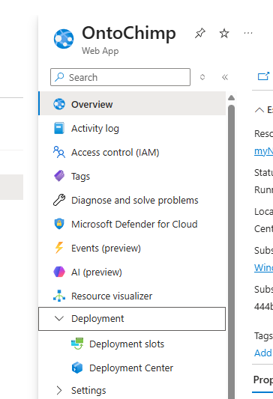

https://learn.microsoft.com/en-us/azure/app-service/deploy-best-practices#use-deployment-slots

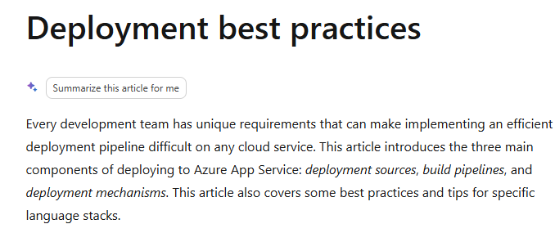
OntoChimpWeb/
│
├── README.md
├── .gitignore
├── requirements.txt
├── environment.yml
│
├── docs/
│ ├── architecture.md
│ ├── roadmap.md
│ └── decisions/
│
├── api/
│ ├── main.py
│ └── routers/
│
├── ontochimp_core/
│
├── tests/
│
└── frontend/

One more suggestion
Since this is likely to involve collaboration with your University of Michigan colleagues, I would make the repository professional from the beginning.
Include a good README.md with sections like:
# OntoChimpWeb

AI-assisted ontology enhancement service.

## Purpose

OntoChimpWeb analyzes biomedical literature to identify candidate ontology classes that may be absent from a target ontology.

## Technology

- Python
- FastAPI
- SQLAlchemy
- MySQL
- Azure App Service
- OpenRouter

## Status

Prototype
That way, if you invite collaborators in a month, they immediately understand the project's goals.
My favorite part of this plan
What I like most is that it changes your mindset.
Instead of asking:
"How do I move my desktop application online?"
you're asking:
"How do I architect a new web service that reuses my proven scientific engine?"
That's a subtle but important distinction. It encourages you to carry forward the valuable parts of OntoChimp while leaving behind desktop-specific assumptions.

